Database Coursework Part 2
HLUM HTET AUNG
40841063

Table of Contents
Feedback Updates 3
Union Table Separation 3
Additional Attributes for technicians and traffic controllers 3
Updated Justifications/Assumptions (From Part 1) 4
Justification/Assumption for keys 5
Updated Queries and Test Plan 5
Aircraft Test Performance Summary (Query 1) 5
Technician Annual Performance (Query 2) 5
Recently Examined Traffic Controllers (Query 3) 6
Aircraft safety check (Query 4) 6
Technician Expertise and Aircraft model summary 6
Query Test Plane 7
Task C 9
Relational Schema 9
Relational Schema Table 10
Normalization 11
First Normal Form (1NF) 11
Second Normal Form (2NF) 12
Third Normal Form (3NF) 12
Task D 13

Feedback Updates
This section mainly focuses on updating the database design and test plan so that it matches the feedback.

Union Table Separation
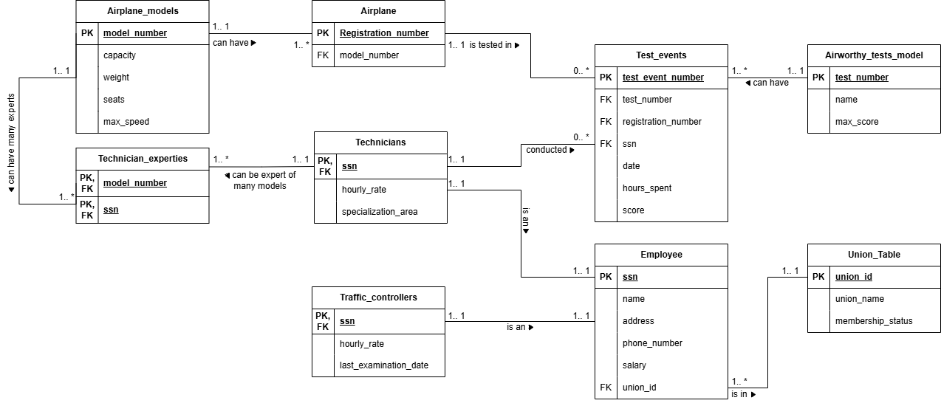
Figure 1 Union Table separated
The union table is separated from employee table for satisfying 3NF in normalization stages. The details for this separation will be discussed further in Normalization (Third Normal Form (3NF)) topic.

Additional Attributes for technicians and traffic controllers
Additional attributes for technicians and controllers are added to ensure that the table is realistic. For technicians, hourly rate and specialization area is added, whereas traffic controllers table has additional hourly rate and last examination date (already exists). These are the unique attributes where Employee table can’t summarize. Hourly rates can be seen in both technicians and traffic controllers.
Note: The hourly rate in subtype tables, although common, is put on respective tables and not employee table is to avoid null values. In employee table, every employee already has a salary amount but not everyone can have an hourly rate where they are paid for overtime or if an employee is non-hourly employee, who has a set amount of salary.

Updated Justifications/Assumptions (From Part 1)
This section of the report will explain the relations between tables in the airport database. The relation between the tables is –
- (Union Table 1:1--------1: * Employee) – A one to many relationships where an employee can belong to at most one labor union, while a single union can represent multiple employees. Union Table’s primary key union_id acts as foreign key in Employee table.
- (Airplane models 1:1--------1: * Airplane) – one to many relations where an airplane model can have many physical registered aircraft, but each plane belongs to one model. Model wide specifications (seats, max speed, capacity, weight) are stored in airplane model tables.
- (Airplane 1:1-------0: * Test events) – one (optional) to many relations where an airplane can optionally have zero or more test events. However, each testing event must be associated with one airplane.
- (Test events 1: *-------1:1 Airworthy test model) – one to many relations where a airworthiness test template can be used across many test events. However, each test event is used in exactly one test model.
- (Test events 0: *-------1:1 Technicians) – optional one to many relations where a test event is conducted by one certified technician, while a technician can perform many test events.
- (Technicians 1:1-------1:1 Employee) – one to one parent and child table relation. Employee stores shared personal attributes for both technicians and traffic controllers, while technician specific attributes are stored in Technicians using ssn as a primary key and foreign key.
- (Traffic controllers 1:1-------1:1 Employee) – table relation and structure are same as technicians and employee, except the specific attributes difference.
- (Technicians 1:1-------1: * Technician expertise) – many to many relations where a technician can be certified for many airplanes
- (Airplane models 1:1-------1: * Technician expertise) – many to many relations, where an airplane models can have one or many certified technicians
There is an original relation between Technicians and Airplane models. However, a composition table is used because it is not possible to store many too many relation without violating first normal form, where there are multi-valued attributes in a table.

Justification/Assumption for keys
This section will discuss the reason for choosing primary keys in the table –
- Natural Primary Key – ssn from Employee table, registration number from Airplane table are chosen because they are guaranteed to be unique for each employee and airplane.
- Surrogate Primary Key – test even number from Test events table, union id from Union table is chosen as auto-incremented surrogate integer keys to avoid using composite keys.
- Shared Primary/Foreign Keys – Technicians table’s ssn and Traffic controller’s table’s ssn are used as both primary key and foreign key to reference employee table. This is to ensure that the relation enforces strict one-to-one relations.

Updated Queries and Test Plan

Aircraft Test Performance Summary (Query 1)
This query monitors how aircraft are tested and how many hours the test event takes, and average test scores the test achieved. This ensures the aircraft are airworthy and can perform flights. By looking at this query management can also monitor the planes’ health and performance.
Tables used – Test events, Airplane, Airplane models, Technicians
Aggregated Functions – COUNT, SUM, and AVG

Technician Annual Performance (Query 2)
For this query, management wants to identify which technicians conduct the most aircraft tests each year. This can help management recognize technicians with high performance and allocate testing work, as well as awarding properly.
Tables used – Employee, Technicians, Test events
Aggregated Functions – COUNT, GROUP BY

Recently Examined Traffic Controllers (Query 3)
This query can provide management with the list of traffic controllers who have recently completed their medical examination. With this query, they can determine which controllers have current medical records and who need another examination.
Tables used – Employee, Traffic controllers

Aircraft safety check (Query 4)
This query can help management determine whether the latest test performed on an aircraft has achieved a score that could satisfy historical average score. This can help management determine if a plane is in good condition and if higher than average score the plane is safe to fly.
Tables used – Test events, Airplane, Airplane models, Technicians, Employee
Aggregated Functions – AVG

Technician Expertise and Aircraft model summary
Management wants to identify which technicians are qualified to work on each aircraft model. This is useful for management to assign technicians properly to each plane that require testing or repair.
Tables used – Technician expertise, Technicians, Airplane models, Employee

Query Test Plane
Test Case | Query | Main Test | Expected Result
TC1 | Aircraft Test Performance Summary | COUNT, SUM, AVG | Correct test counts, total hours and average scores
TC2 | Technician Annual Performance | COUNT, SUM, GROUP BY | Correct tests and total hours per technician
TC3 | Recently Examined Traffic Controllers | Date filtering | Only recently examined controller returned
TC4 | Aircraft Safety Check | Correlated subquery + AVG | Correct model average and Pass / Review Required results
TC5 | Technician Expertise Summary | Multiple joins | Correct technician-model relationships
Table 1 Query Test Plan Table

Expected Result for Query 1 with sample data
Model Number | Registration Number | Technician SSN | Number of Tests | Total Test Hours | Average Test Score
A320 | 101 | 1001 | 3 | 7.5 | 88.33
A320 | 102 | 1002 | 2 | 7.0 | 75.00
B737 | 103 | 1003 | 2 | 4.5 | 90.00
Table 2 Expected Results for Query 1

Expected Result for Query 2 with sample data
SSN | Technician Name | Test Year | Total Tests | Total Hours
1001 | John Smith | 2026 | 5 | 12.5
1002 | Sarah Brown | 2026 | 2 | 7.0
Table 3 Expected Results for Query 2

Expected Result for Query 3 with sample data
SSN | Name | Last Examination Date
1004 | Emily Davis | 2026-06-15
Table 4 Expected Results for Query 3

Expected Result for Query 4 with sample data
Model Number | Registration Number | Technician Name | Latest Score | Model Average Score | Safety Status
A320 | 101 | John Smith | 95 | 83.00 | Pass
A320 | 102 | Sarah Brown | 80 | 83.00 | Review Required
Table 5 Expected Results for Query 4

Expected Result for Query 5 with sample data
SSN | Technician Name | Model Number
1001 | John Smith | A320
1001 | John Smith | A330
1002 | Sarah Brown | A320
Table 6 Expected Results for Query 5

Task C

Relational Schema
The entity relation diagram of the airport database system includes 3 main tables – Employee, Airplane, and Test Events. These tables have sub-tables, lookup tables, and composite tables that join them together. The relational schema of the database system is –
Employee (social security number, name, address, phone number, salary, union id)
Union (union id, union name, membership status)
Airplane (registration number, model number)
- Model number → Airplane models (model number)
Test Events (test event number, test number, registration number, social security number, date, hours spent, score)
- Test number → Airworthy test model (test number)
- Registration number → Airplane (Registration number)
- Social security number → Technicians (social security number)
Technicians (social security number, hourly rate, specialization area)
- Social security number → Employee (social security number)
Traffic controllers (social security number, hourly rate, last examination date)
- Social security number → Employee (social security number)
Airworthy test model (test number, name, max score)
Airplane models (model number, capacity, weight, seats, max speed)
Technicians’ expertise (model number, social security number)
- Model number → Airplane models (model number)
- Social security number → Technicians (social security number)
*Note: The underlined attributes are primary key, and the italic attributes are foreign key.
Figure 2 Updated Airport Database ERD

Relational Schema Table
Table Name | Attributes | Primary Key | Foreign Key
Union | Union id, union name, membership status | Union id | None
Employee | Social security number, name, address, phone number, salary, union id | Social security number | Union id
Technicians | Social security number, hourly rate, specialization area | Social security number | Social security number
Traffic controllers | Social security number, hourly rate, last examination date | Social security number | Social security number
Airplane models | Model number, capacity, weight, seats, max speed | Model number | None
Airplane | Registration number, model number | Registration number | Model number
Airworthy test model | Test number, name, max score | Test number | None
Test event | Test event number, test number, registration number, social security number, date, hours spent, score | Test event number | Test number, registration number, social security number
Technicians’ expertise | Model number, social security number | Model number, social security number | Model number, social security number
Table 7 Relational Schema Table

Normalization
The database tables are normalized into 3NF. The normalization was done since the implementation of entity relation diagram, with minor changes in part 2.

First Normal Form (1NF)
The tables in the database are in first normal form because –
- Singular values – All attributes store single value in each cell. For example, phone number column stores a single string, score stores a single numerical value.
- No Repeating Groups – The database uses Technicians’ expertise composite table to capture expertise relationships as individual rows, instead of storing multiple certifications inside Technicians table.
- Primary Keys – Every relation in the schema has a defined Primary Key.

Second Normal Form (2NF)
As the table already satisfy first normalization, it also satisfies second normal form as the attributes have –
- Single-Column Primary Key – For every table except for bridge tables, the primary key consists of a single attribute. For this reason, every attribute in the table depends solely on their primary key and partial dependency is impossible.
- Composite Primary Key – For the composite tables the composite keys model number and social security number are the only attributes and there are no non-key attributes in the table. Thus, there is no partial key dependency in this table.

Third Normal Form (3NF)
The tables from the database are also in 3NF because –
- They satisfy both 1NF and 2NF.
- Separation of Union Data – After separating union table and the employee table, the transitive attributes in the employee tables, where a non-key attribute depending on another non-key attribute is eliminated.
- Separation of Model Specifications – Storing model specifications (capacity, weight, seats, max speed) directly in Airplane table like in part 1 diagram creates transitive dependency. To fix this, these dependencies are relocated into Airplane Model table to ensure non-key attributes in Airplane table depend directly on its primary key (registration number).
- Subtype Tables (Technicians and Traffic controllers) – While attributes that are common for both technicians and traffic controllers are stored in Employee table, they also have their specific values (specialization area, hourly rate, and last examination dates) that depend directly on their primary key social security number within Technicians and Traffic controllers’ tables.

Task D

